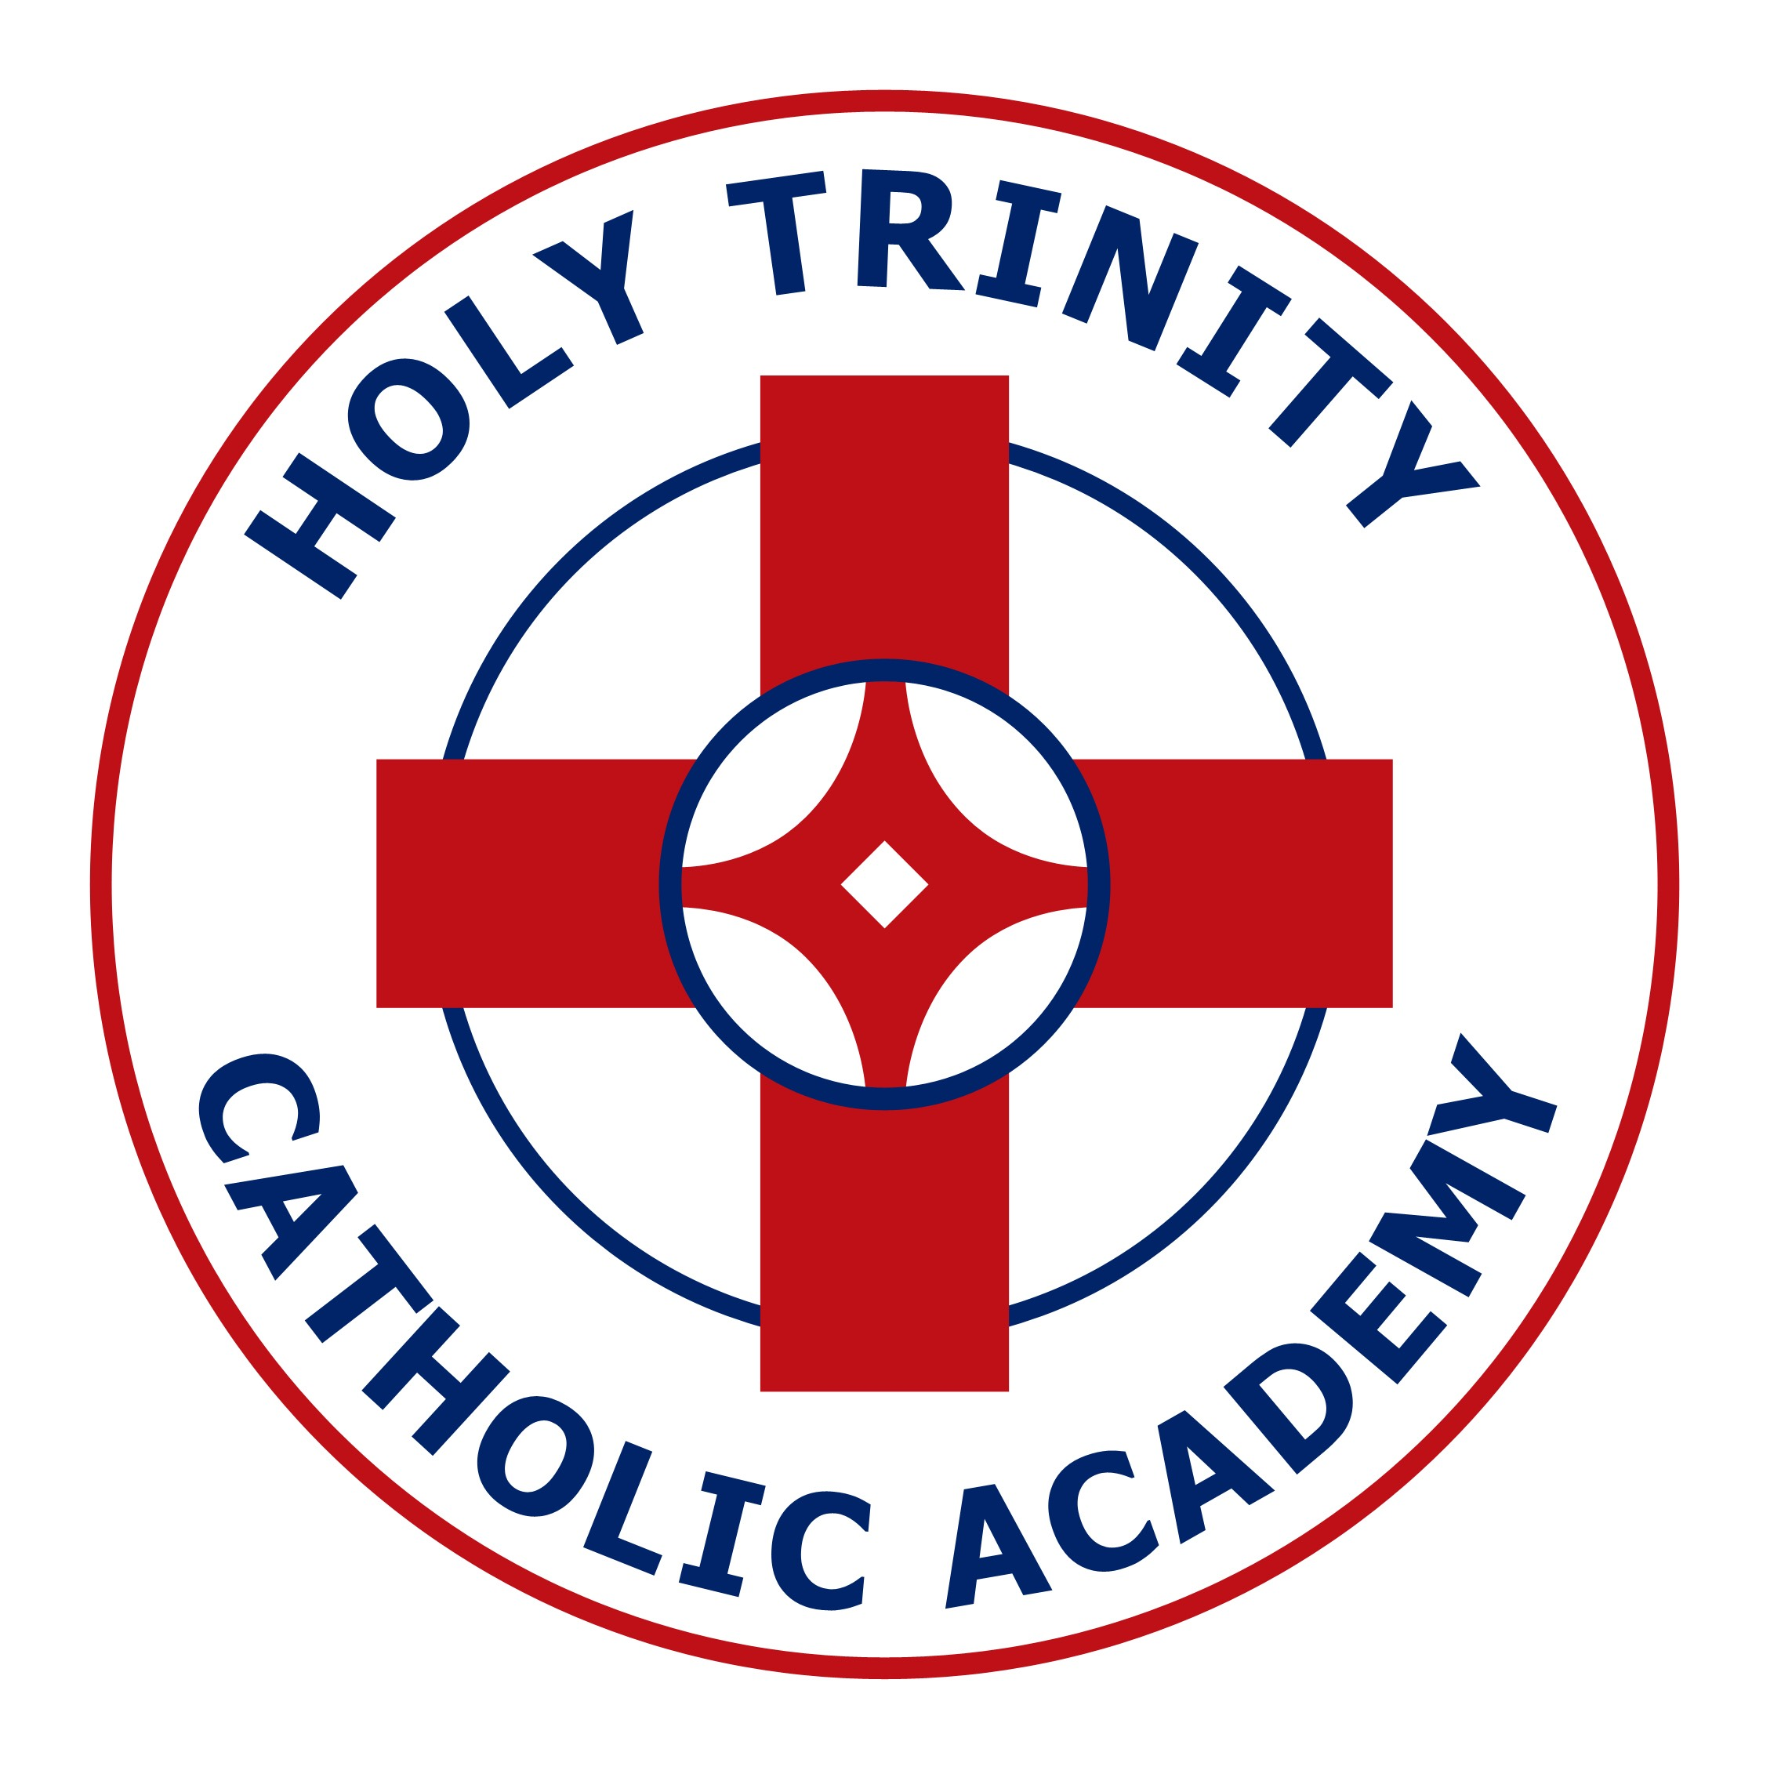
HOLY TRINITY CATHOLIC ACADEMY

NURSERY APPLICATION FORM

Name
Date of Birth
Address
Telephone Number
Email Address

Religion
Mother’s Name

Father’s Name

First Language

Does your child have any special needs? |  | Yes | No
* Preferred Session? |  | Morning | Afternoon | All Day
If All Day do you receive 30 hours funding? |  | Yes | No
Signed

Date

* Morning only or Afternoon only sessions are free.

Please complete this form and return it to the school office with your child’s birth and baptismal (if applicable) certificates.

